Ortiz Guzman, Julio

20 September, 2021

ECe 3200-01 Lab 4

Common-Emitter (CE) Amplifier Biasing and AC Measurements (Mid-band Frequency Range)

**Objective:**

The objective of this lab is to design a CE amplifier to meet a specific bias requirement and measure its small signal voltage gain (Av), the input impedance (Ri) and the output impedance (Ro) to validate the result with the hybrid-pi model.

**Prelab:**

**Procedure:**

1. Assemble the circuit of fig 1 with your calculated values and measure the Q-points.

ICq = 1.098 mA , VCEq = 5.277 V , VEq = 2.441 V , VBq = 3.083 V

1. Set the signal generator output vg = 30 mVpp at 5 kHz. Make sure the output is a clean sinusoidal waveform free from distortion.
2. Measure the signals vi(green) and vo(red).

Compute the voltage gain from Av = vo / vi ……..(1)

Av = 13.5418

1. Compute the input signal current, i­in, from iin = (vg – vi) / Rg.

Then compute the small signal input impedance Ri from,

Ri = vi / iin 2.084 kΩ (2)

1. Now introduce the variable load resistor, RL, by connecting to the circuit. Note the output amplitude will drop. Continue decreasing RL till the output amplitude halves.

Remove RL and measure its resistance. The value is the equivalent to the output resistance at the output terminal (or equivalent to the Thevenin resistance viewed towards the circuit).

RL = Ro = 1 kΩ (3)

1. From the data obtained in (1),(2) and (3) compose an equivalent circuit (a model) comprised of an input stage resistance, a dependent voltage source and an output resistance.

1. Measure the power gain of the stage, Ap, when the load resistance is RL = 6k.

Ap = Po / Pi = (vo2 / RL) / ( vi2 / Ri ) = (Ri / RL )( vo / vi )2 =

= (Ri / RL )Av2(Loaded) = 63.7 (4)

Where Pi is the input power, Po is the output power and Av(Loaded) is the voltage gain under the loaded condition.

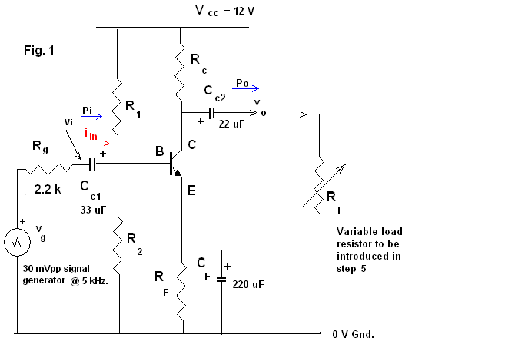

**Measurements:**

**IR1 = 1.2371 mA, Ic1 = 1.3563 mA, Ic4 = 1.2503 mA, Ic5 = 1.4193 mA, Vo= 1.7378V (measured)**

**Analysis & Results:**

1. **Calculations:**

Calculate all the specified values using basic device concept and circuit theories.

IR1 = 1.24 mA, Ic1 = 1.31 mA, Ic4 = 1.17 mA, Ic5 = 1.35 mA, Vo=1.52 V (calculated)

1. Calculate the % of variation between the measured values and the calculated ones and record it below:

IR1 (%) = 0.233871%, Ic1(%) = 3.53435%, Ic4(%) = 6.86325%,

Ic5(%) = 5.13333%, Vo (%) = 14.3289% (% of variation)

Av = Vo / Vi = 1.7378V/ 2V = 0.87 (measured)

Av = Vo / Vi = 1.52V/ 2V = 0.76 (calculated)

**CONVERTING THE CIRCUIT TO AN AC AMPLIFIER ( Pspice Simulation):**

Show how this circuit can be transformed into a high gain AC amplifier by inserting bypass and coupling capacitors in **appropriate** locations. **Construct the circuit in Pspice**. Apply ac simulation by using a 1kHz, vi = 2 mVpp sinusoidal input and print the output ( vo ) and attach to your report . Compute the ac voltage gain (Av = vo / vi ) from the result of simulation and present in your report . You may use 470 uF capacitors to bypass the ac signals.

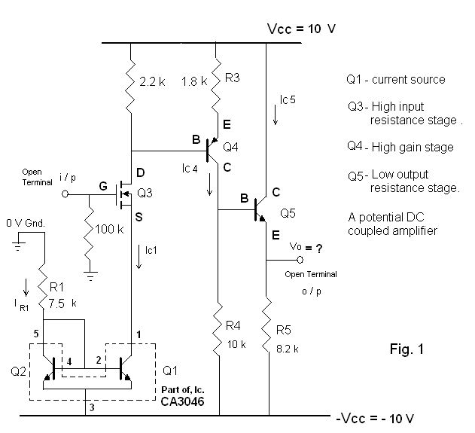

**Conclusion:**

Through this lab, I was able to better understand how to make a basic CE amplifier to meet specific predetermined bias conditions. We were required to measure the small signal voltage gain of the CE amplifier circuit, the input impedance and the output impedance of the circuit displayed in Fig 1. Although I was not able perform the lab physically, I was still able to visualize and understand the circuit with the help of PSpice, and the zoom meeting provided. This lab was quite helpful in bettering my ability to design a small signal amplifier based off given quiescent values and in understanding the AC response on a CE amplifier.